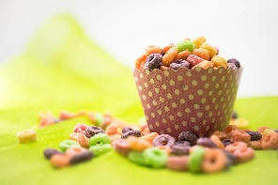
Elementary Breakfast Menu
June 2nd-11th

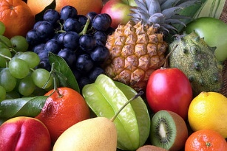
Monday, June 2nd
Cinni Minnis
Tuesday, June 3rd
Pancake on a Stick
Wednesday, June 4th
Blueberry Waffles
Thursday, June 5th
Egg & Cheese on a Bagel
Friday, June 6th
Chocolate Chip Pancakes

Monday, Tuesday, and Wednesday, June 9th, June 10th and 11th
Chef’s Choice

All breakfasts are served with fruit and milk
Menu subject to change
Have a great summer 2025!
Jennifer M. Mullin, SNS Washington TWP Food Service Manager
856-582-4010
Please look for the 2025-2026 SCHOOL MEAL AND S-EBT APPLICATION coming out soon

